Noel Miranda

September 5, 2024

Assignment 4.2

**MySQL Install**

**Initial Database Connection:**

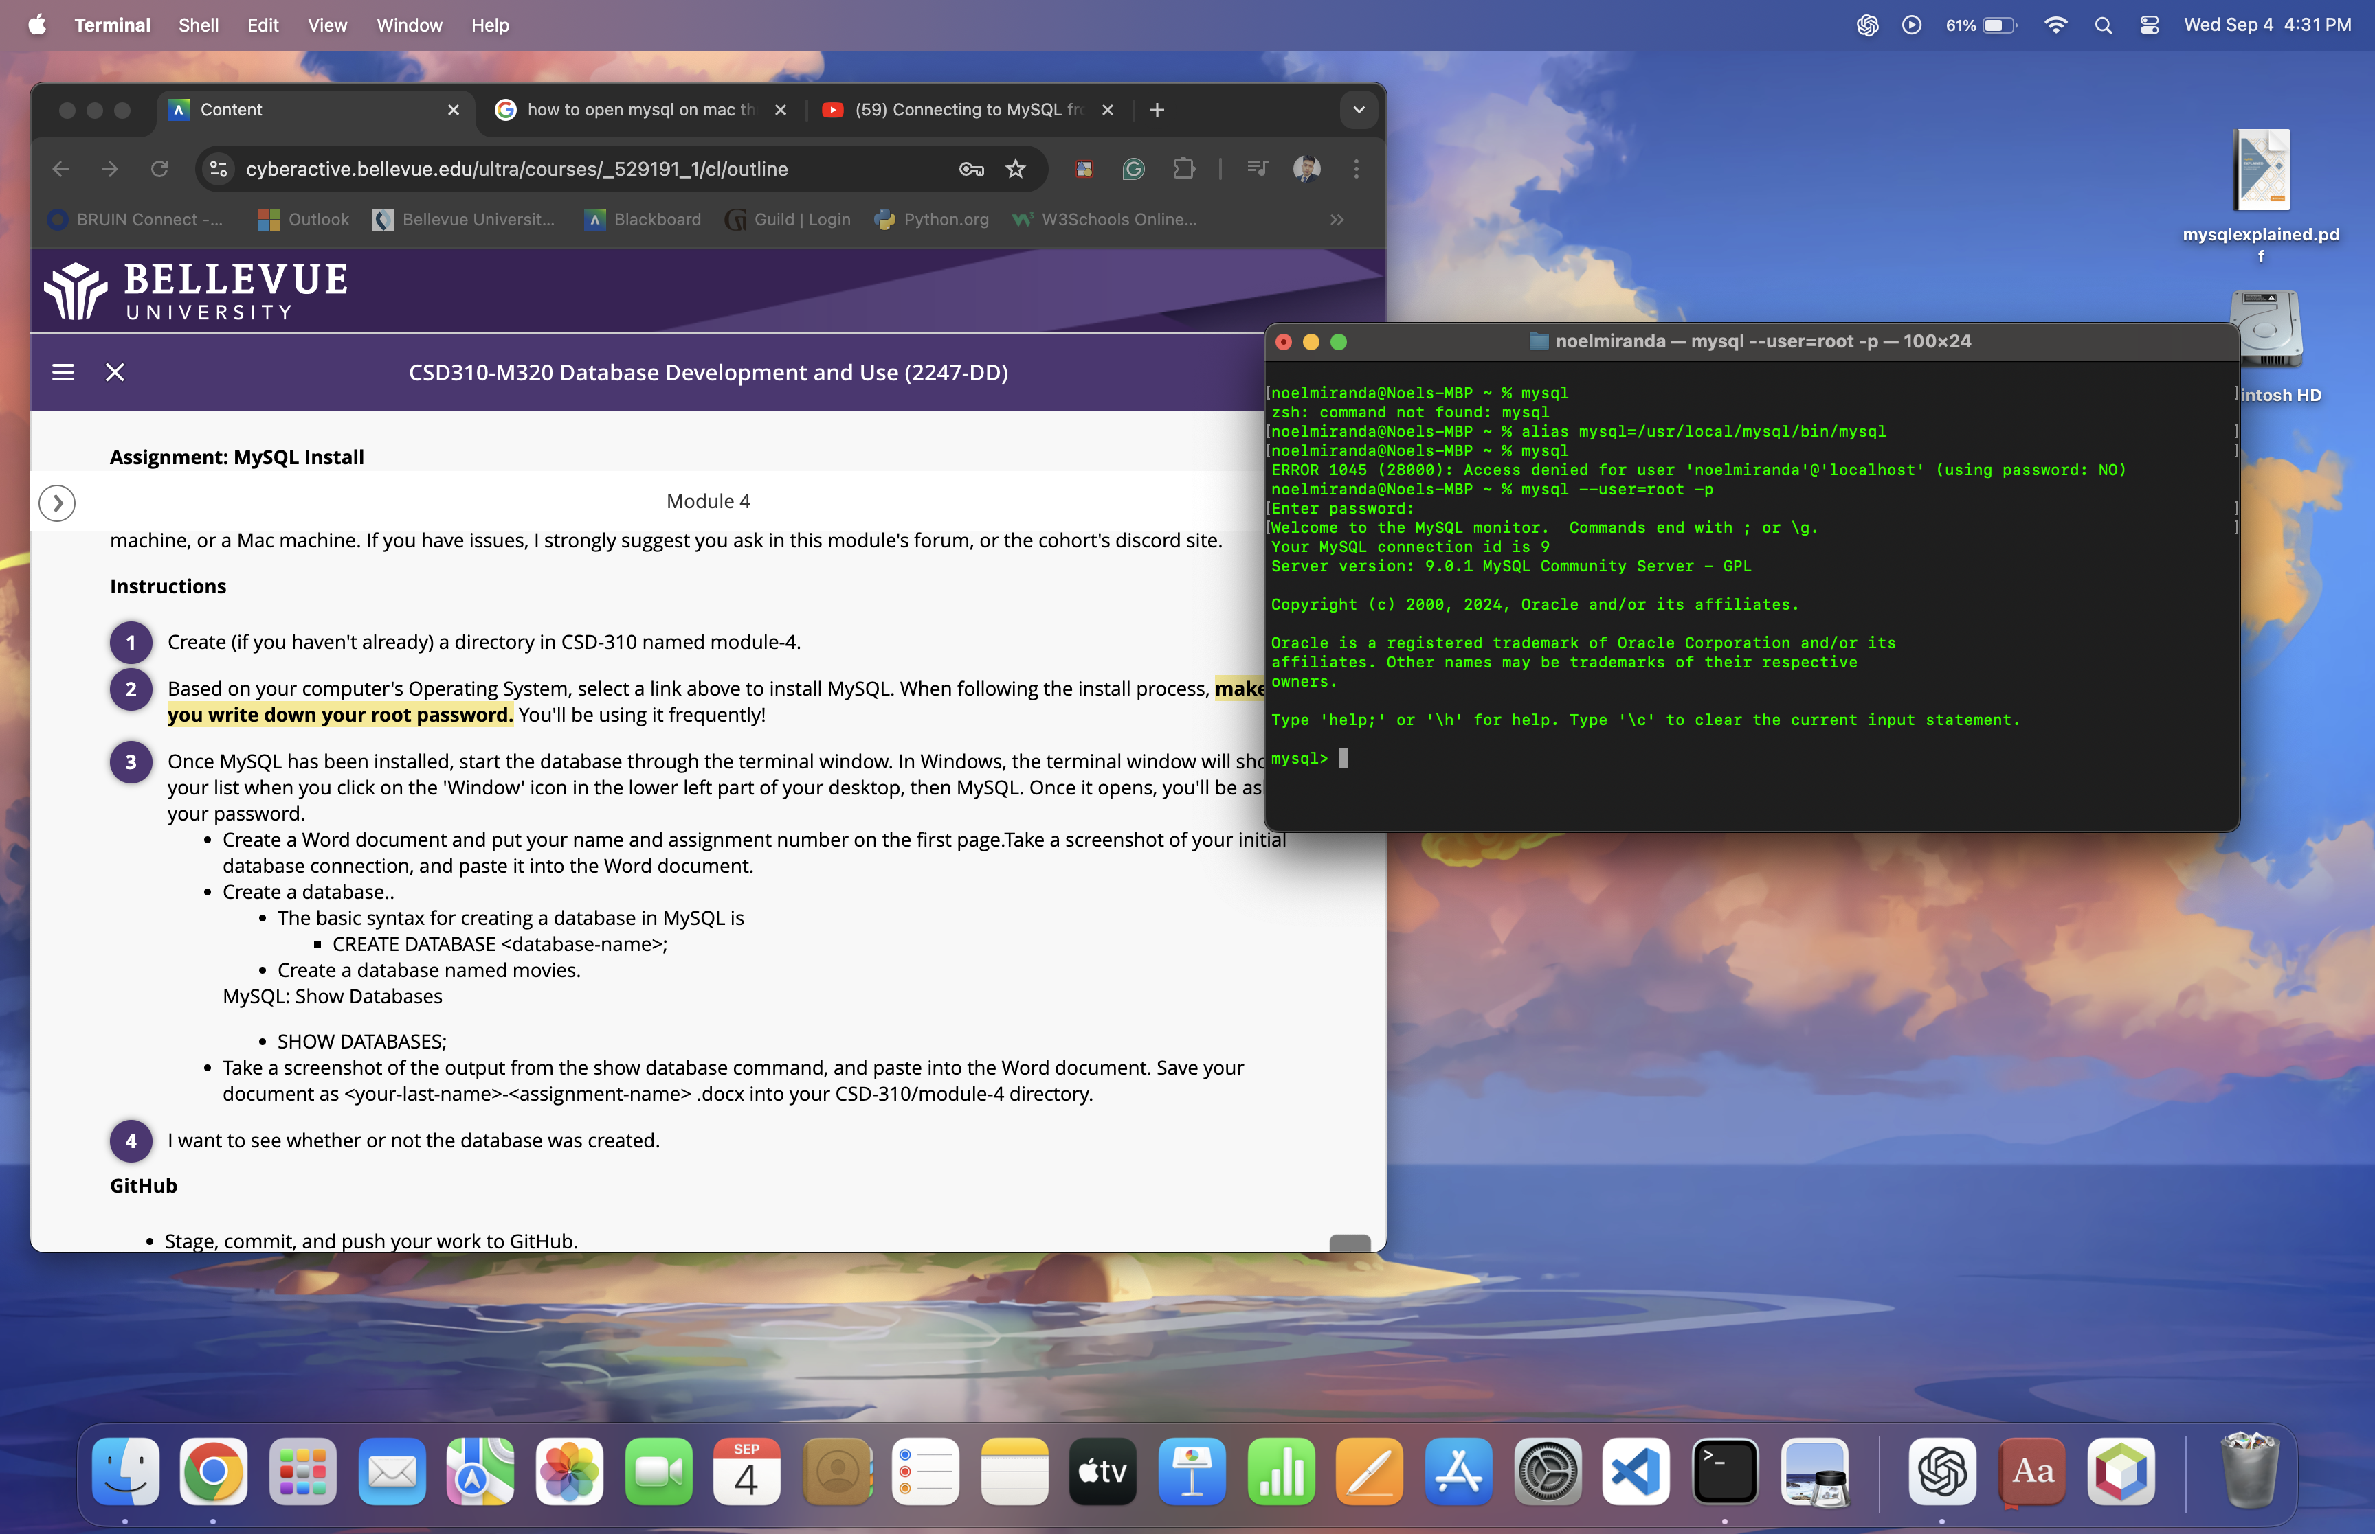

**Output from Show Database Command:**

